[Test Plan] Belajar Bareng Onrender version 1.0

Document Status | [DRAFT]
Test Plan Creator | Riska Apriliyanti
Test Plan Reviewer | - M Ridhwan K

Introduction

Overview Feature to be tested
This Test Plan is made to ensure that all features on the belajar-bareng.onrender.com website function properly and meet the criteria according to user needs.

Goals and Objective
.
The Belajar-bareng.onrender.com website simulates a simple online store (e-commerce) with features such as a login page, user management, and checkout. Phase 1 of feature testing was conducted using manual testing to test the following features:
- Testing the Login page features aims to ensure users do not experience problems when performing the login process. The test scenario is to use a valid/invalid username and password.
- Testing the Add User feature aims to ensure that users can add users by entering valid usernames and ages.

Test Item
List of test items (feature / product)

No | Feature | Test Item
#1 | Login | - Login with valid credentials  - Login with empty Username  - Login with empty Password  - Login with invalid credentials  - Login with user doesn’t exist
#2 | Add User | - Success Add User with Input Valid Username dan Age  - Input Username with 9 Character

In Scope Testing
List of in feature to be tested

No | Feature | Requirement / Design specifications
#1 | Login | 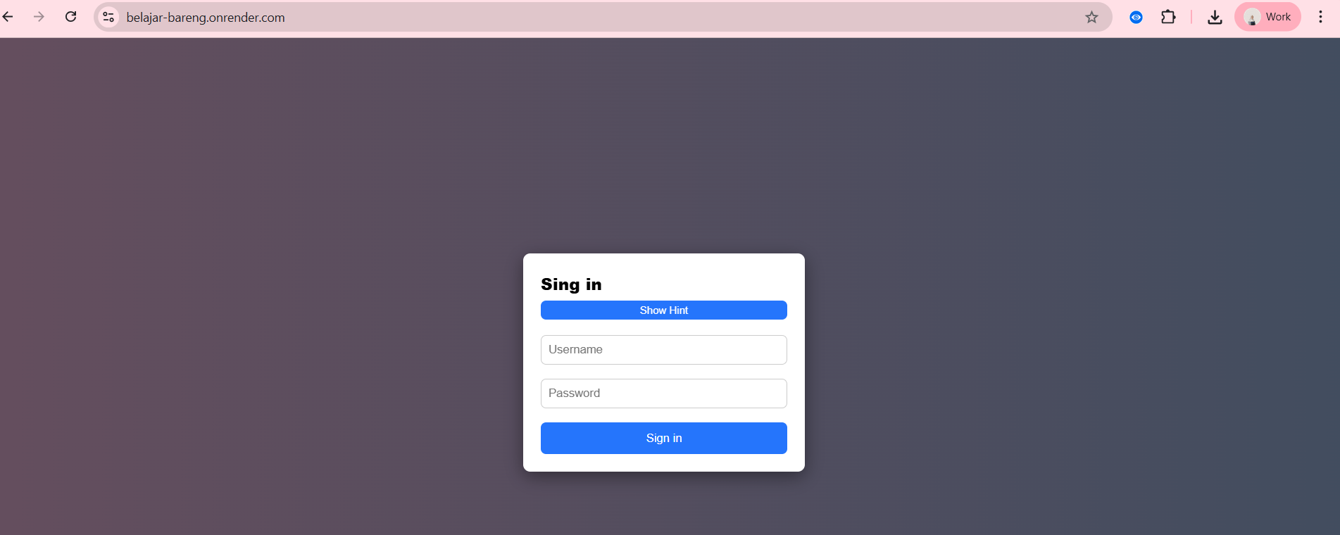
#2 | Add User | 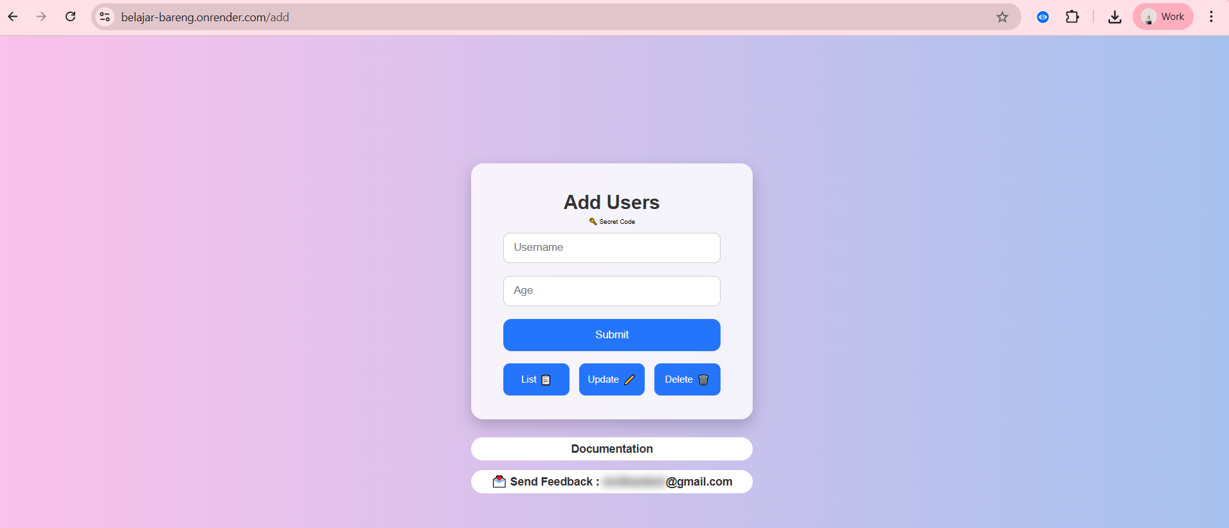

Out of Scope Testing
List the features of the software / product which will not be tested.

No | Feature | Reasons
#1 | Update Users | This testing phase will be focus to test login and Add User feature
#2 | Delete Users | This testing phase will be focus to test login and Add User feature
#3 | Checkout | This testing phase will be focus to test login and Add User feature

Testing Approach
The testing process uses Exploratory testing type because the tester does not know from the beginning the process of making the belajar-bareng.onrender.com website. So that the tester explores the website to test whether the website is suitable and can be used by users without any problems.

Test Environment
Information about testing environment that will be used during testing phase e.g URL, and version of App
- Website: https://belajar-bareng.onrender.com/
- Android version: -
- iOS version: -
- Env: Production
- Browser: Edge, Chrome, Firefox

Test Deliverables
- Test Plan (this document itself): [link]
- Test Case: [link]
- Test Script (if any): -
- Test data (if any): -
- Defect Report: -
- Test Report: -

Testing Timeline

No | Task | Estimation Time |  | Actual Time
No | Task | Start Date | Finish Date | Start Date | Finish Date
#1 | Develop Test Planning | 26 Jan 2026 | 26 Jan 2026 | 26 Jan 2026 | 26 Jan 2026
#2 | Develop Test Case | 26 Jan 2026 | 26 Jan 2026 | 26 Jan 2026 | 26 Jan 2026
#3 | Test Case Review | 01 Feb 2026 | 01 Feb 2026
#4 | Execute Test | 01 Feb 2026 | 01 Feb 2026

References
List of related documents e.g PRD, Figma design, API Contract, Copy document etc

API Contact: https://belajar-bareng.onrender.com/documentation
Design: -

